Prescriptive Tables to Be Used In Performance

* Dry System Equipment, Column 2. Let me know if you need help mapping them to the existing terms.

|  |
| --- |
| Unitary AC/ Condensers |
| Unitary AC/ Cond. (no elec. resistance) |
| Unitary heat pumps |
| Unitary heat pumps (no elec. resistance) |
| PTAC/ PTHP |
| SPVAC/ SPVHP |
| Variable Refrigerant Flow |
| Furnace/ Unit heater |
| Computer Rm AC |
| ~~Heat Pump + AC~~ Sm. Commercial AC |
| ~~Split~~ Furnace + AC |
| ~~Pkg Furnace + AC~~ |
| Room AC/HP |

* Indoor Conditioned Mandatory Lighting Controls, 1 row at the bottom per zone. I showed the screenshot with two zone show what it would look like when expanded

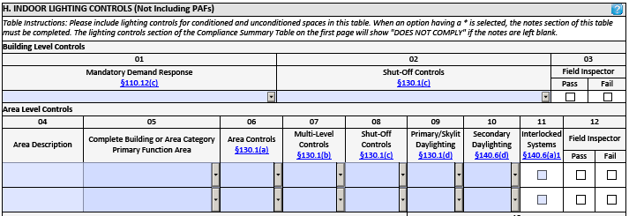

* Tailored Tables. K is main table that summarizes all of tailored method allowed watts, methods used, and area. L, M, N, O are one table per method. Only the tables that apply would trigger.

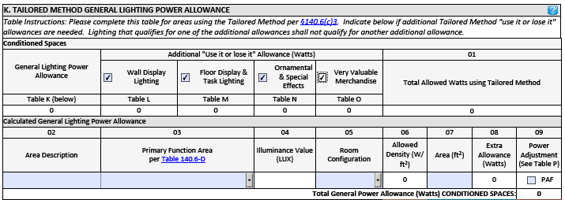

Ignore the “Add/Remove” buttons

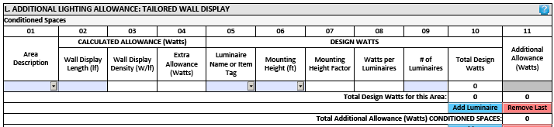

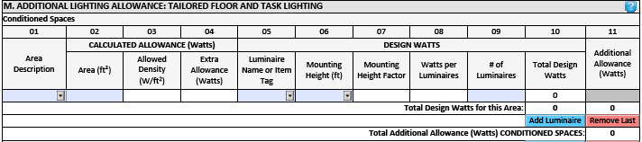

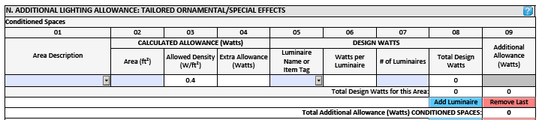

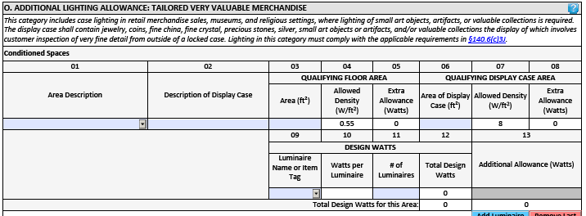

If you need help with the possible dropdowns or how the tables would look with additional zones/luminaires reach out and I can explain.